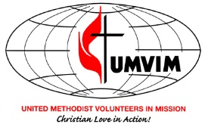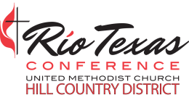
Volunteers In Mission Training
September 23, 2017 9:00 am -3:30 pm
First UMC Johnson City
Now that we are well into the initial phase of early response (ERT) to Hurricane Harvey, it’s time to begin planning and training for the long-term recovery which will last for the next two years or more. This event will train and qualify volunteers for DISASTER RECOVERY TEAMS to go into affected localities to perform extensive repairs and reconstruction of homes, churches, and other buildings, in contrast to the work done by Early Response Teams. Ideally, we hope a team from a local church or from several nearby churches will sign up for this training, but it is also for individuals who want to be trained and are willing to be assigned to a team working in a particular locality.
For those of you who were not able to put your feet on the ground in the initial stages of this disaster in the Coastal Bend, please consider registering for this training event.
Cost of the training:
manual: $25
lunch $11.00
Church teams can pay for one (1) manual and then just for lunch per person. Any of the team wanting their own manual will have to pay $25
You may mail payment to Hill Country District or pay at the door. If you have any questions feel free to contact:
Pam Elliott, Hill Country District VIM Coordinator-dispro512@gmail. Com
Abel Vega, RTC Mission Vitality Outreach Director – avega@riotexas.org
Frank Rojas, RTC VIM Conference Coordinator - vim.riotx@gmail.com or 512.422.0210
REGISTRATION IS ON THE BACK OF THIS SHEET

REGISTRATION FORM –Mail this form to the:
Hill Country District Office
222 Sidney Baker South, Suite 528
Kerrville, TX 78028
OR FAX to 830-896-6407 or register by phone at 830-896-6400 OR email kdumc@kdumc.org
Church Name: _________________________Address:_________________________________
Name: ________________________________Name: __________________________________
Name: ________________________________Name: __________________________________
Name: ________________________________Name: __________________________________
Name: ________________________________Name: __________________________________
Name: ________________________________Name: ______________________________

The mission philosophy of the UMVIM program is to demonstrate Christ’s “Love in Action” by working with individuals and communities, so that they can become self-sufficient and have their relationship to God and neighbor restored. VIM teams bring the light back into the lives of those in need. The VIM program offers the opportunity for Christians to grow in their discipleship. It provides the theological foundation for missional living, while teaching the skills to partner with and to be culturally sensitive to the needs of those we serve.

